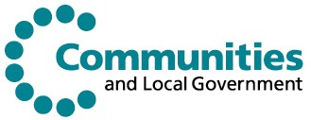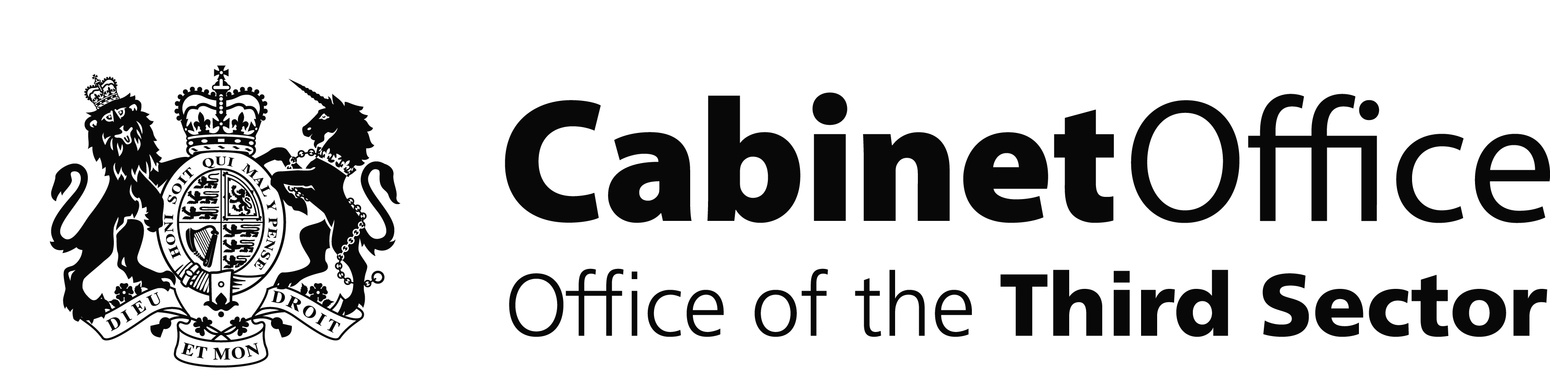
REACH

REACH: Raising the aspirations and attainment of Black boys and young Black men

Regional Workshops:

Supporting Those who Support Young Black Men

Regional Events will be held in London (31 March), Bristol (1 April), Nottingham (3 April), Manchester (21 April) and Birmingham (22 April)*

- Are you working for a Black-led third sector organisation? or
- Do you undertake work to improve life chances for young Black men? or
- Do you support, commission services or offer funds to such organisations?

These workshops will provide you with an opportunity to meet with organisations in your area with similar aims and objectives, representatives from organisations who support infrastructure building in voluntary organisations, and those who commission services and provide funding. You will get the chance to share best practice, get tips on how to access funding and influence Central Government thinking.

During the workshop you will:
- Take part in discussions groups that will cover topics such as
  - the potential impact of working in partnership with other organisations to access funding,
  - the importance of accessing sustainable funding, and;
  - how your experiences could shape Central Government guidance

- See presentations on engaging with commissioners, from both a commissioner and a local VCS/third sector organisation

- Have an opportunity to share lessons learned with a local third sector organisation that has developed a successful funding relationship

This is your opportunity to let us hear your views and to share in best practice. For more information about REACH visit our website http://campaigns.direct.gov.uk/reach/

To confirm your participation please contact: anne.utulu@communities.gsi.gov.uk t: 0207 944 0546

